Hands-on 7 - Add a new country

Name: Shubham Sangram Bej

Aim
To add a new country to the database using Spring Data JPA Repository.

Theory
Spring Data JPA provides the save() method to insert new records into the database. When the primary key does not already exist, the save() method performs an insert operation. The @Transactional annotation ensures that the insertion is committed successfully.

Procedure
- Create addCountry() method in CountryService.
- Invoke countryRepository.save().
- Create a new Country object.
- Set country code and name.
- Call the service method.
- Verify insertion in MySQL.

Screenshots
- Project Structure
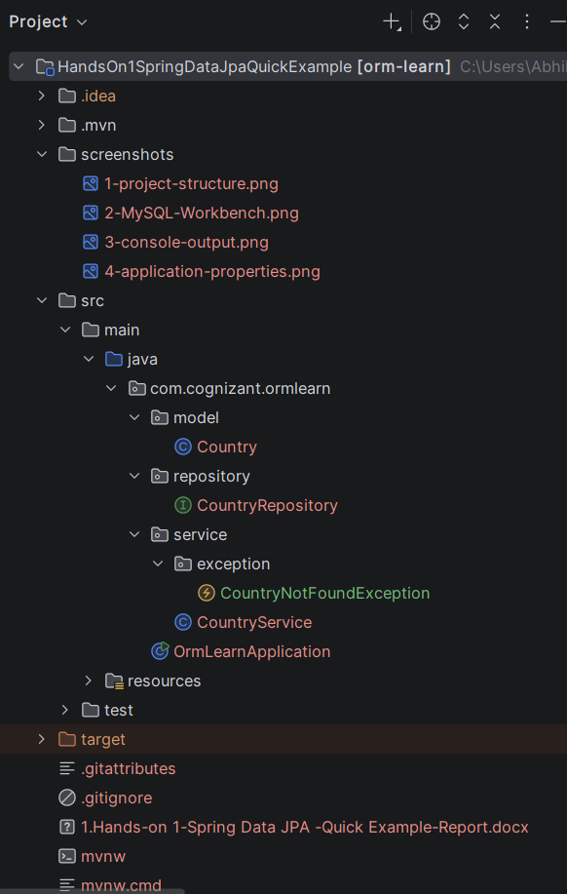

- CountryService.java
package com.cognizant.ormlearn.service;
import com.cognizant.ormlearn.model.Country;
import com.cognizant.ormlearn.repository.CountryRepository;
import org.springframework.beans.factory.annotation.Autowired;
import org.springframework.stereotype.Service;
import org.springframework.transaction.annotation.Transactional;
import java.util.Optional;
import com.cognizant.ormlearn.service.exception.CountryNotFoundException;
import java.util.List;
@Service
public class CountryService {
@Autowired
private CountryRepository countryRepository;
@Transactional
public List<Country> getAllCountries() {
return countryRepository.findAll();
}
@Transactional
public Country findCountryByCode(String countryCode) throws CountryNotFoundException {
Optional<Country> result = countryRepository.findById(countryCode);
if (!result.isPresent()) {
throw new CountryNotFoundException("Country not found with code: " + countryCode);
}
Country country = result.get();
return country;
}
@Transactional
public void addCountry(Country country) {
countryRepository.save(country);
}
}

- OrmLearnApplication.java
package com.cognizant.ormlearn;
import com.cognizant.ormlearn.model.Country;
import com.cognizant.ormlearn.service.CountryService;
import org.slf4j.Logger;
import org.slf4j.LoggerFactory;
import org.springframework.boot.SpringApplication;
import org.springframework.boot.autoconfigure.SpringBootApplication;
import org.springframework.context.ApplicationContext;
import java.util.List;
@SpringBootApplication
public class OrmLearnApplication {
private static final Logger LOGGER =
LoggerFactory.getLogger(OrmLearnApplication.class);
private static CountryService countryService;
public static void main(String[] args) {
ApplicationContext context = SpringApplication.run(OrmLearnApplication.class, args);
LOGGER.info("Inside main");
countryService = context.getBean(CountryService.class);
testGetAllCountries();
testFindCountryByCode();
testAddCountry();
}
private static void testGetAllCountries() {
LOGGER.info("Start");
List<Country> countries = countryService.getAllCountries();
LOGGER.debug("countries={}", countries);
LOGGER.info("End");
}
private static void testFindCountryByCode() {
LOGGER.info("Start");
try {
Country country = countryService.findCountryByCode("PT");
LOGGER.debug("Country={}", country);
} catch (Exception e) {
LOGGER.error(e.getMessage());
}
LOGGER.info("End");
}
private static void testAddCountry() {
LOGGER.info("Start");
Country country = new Country();
country.setCode("ZZ");
country.setName("Shubham's Land");
countryService.addCountry(country);
try {
Country addedCountry = countryService.findCountryByCode("ZZ");
LOGGER.debug("Added Country={}", addedCountry);
} catch (Exception e) {
LOGGER.error(e.getMessage());
}
LOGGER.info("End");
}
}

- Console Output
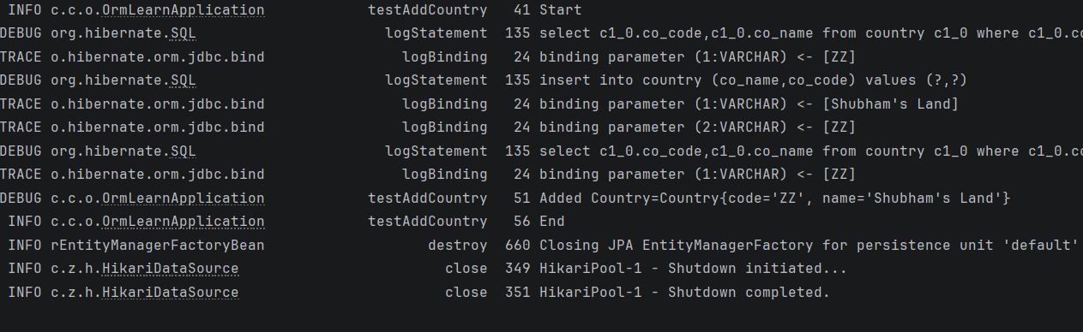

- MySQL Output
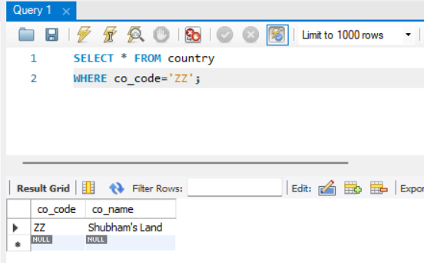

Result
The new country was successfully inserted into the database using Spring Data JPA.

Conclusion
The save() method successfully inserted a new entity into the database, demonstrating the insertion capability of Spring Data JPA.

